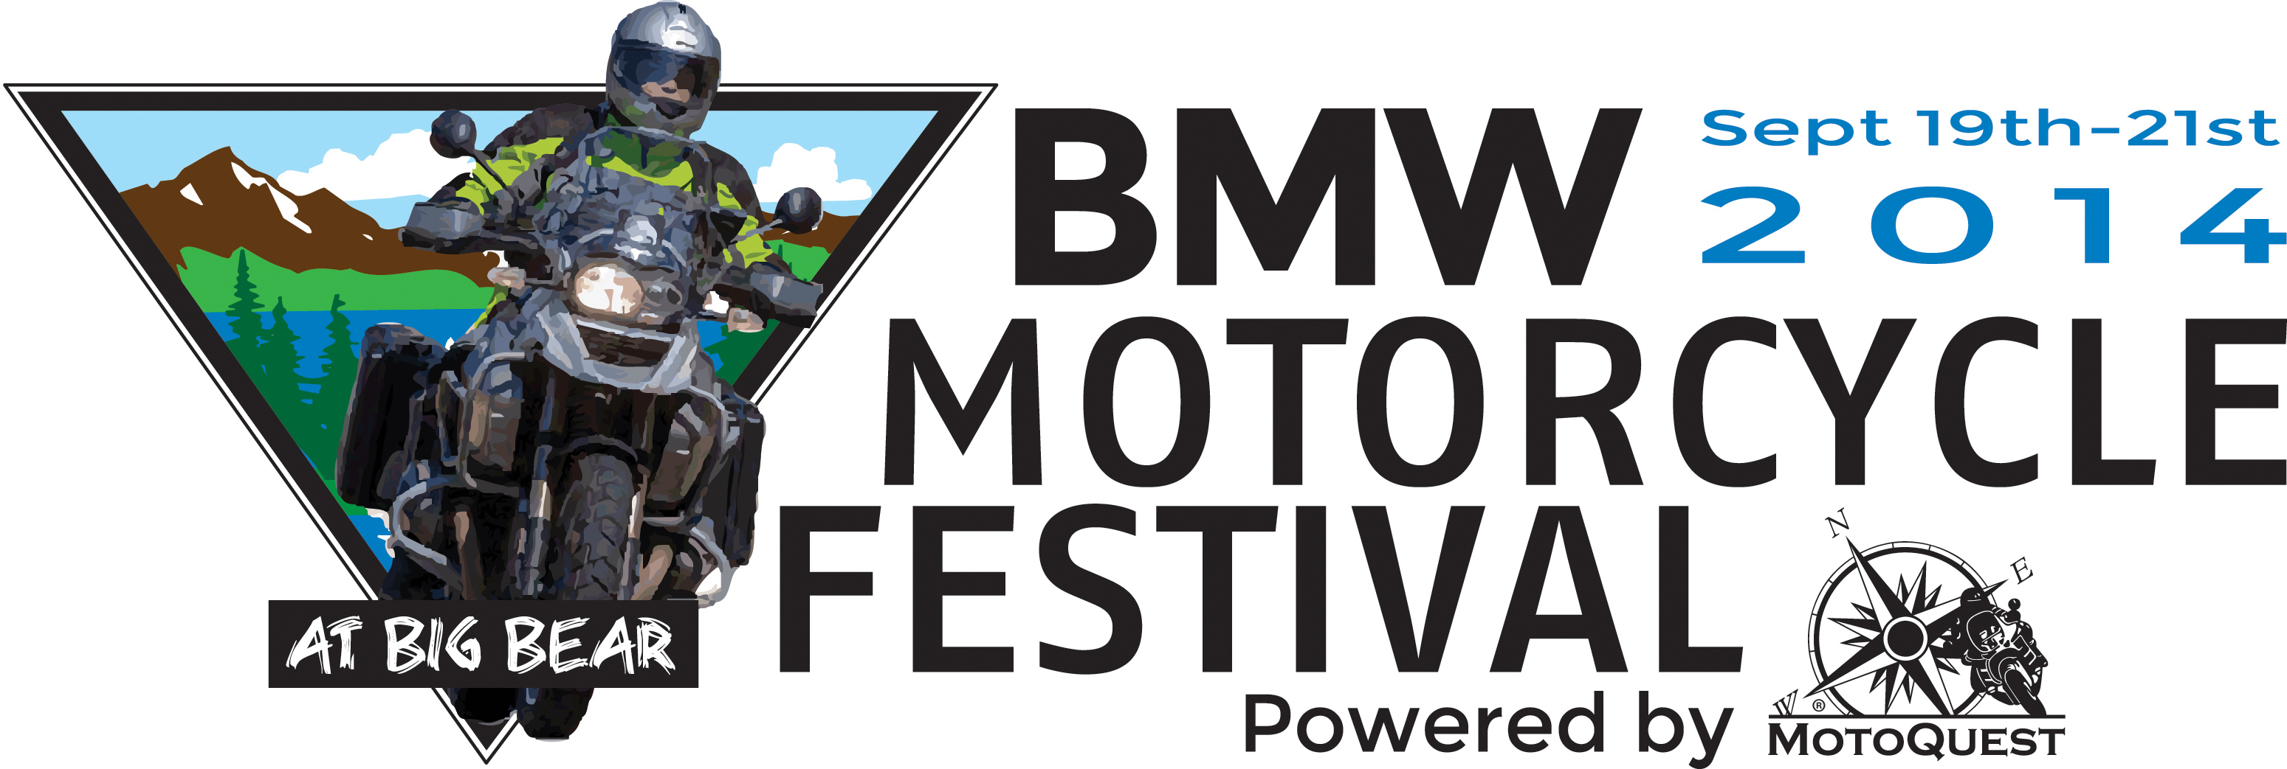

So Cal BMW Motorcycle Dealers Presents BMW Motorcycle Festival at Big Bear

Southern Calif. - July 21, 2014 - The members of So Cal BMW Motorcycle Dealers Group have partnered with MotoQuest to create an all-new festival celebrating BMW Motorcycles and motorcycling culture at Snow Summit Resort in Big Bear, CA September 19th-21st. This BMW Motorcycle Festival will feature guided and self-guided test rides both on and off road on the latest machines from BMW Motorrad, seminars from event sponsors like Schuberth Helmets and Twisted Throttle, and excellent riding through the mountains of Southern California. World traveler and author Glen Heggstad will be featured Saturday night with his exciting tales of danger, beauty and people riding a BMW through more than 50 countries. The vendor and entertainment participants are still growing, so stay tuned for updates.

“Since Test Rides from our dealerships may not include the beautiful mountain roads that BMW’s are made for, we decided to bring a Real World Demo Experience up to the alpine setting of Big Bear CA,” said a So Cal BMW Motorcycle Dealers Group representative. “With great weather and even better roads and trails, you will be able to really see for yourself how capable the new R1200GS is offroad, or how the S1000RR handles on a curvy mountain road. With a fleet of on and offroad BMWs to ride, you can ride a K1600 in the morning and perhaps a GS on the trail in the afternoon and really see what bike is best for you. Here’s the best part; if any BMW Festival participant were to purchase a new BMW from any participating BMW dealer within 6 months, they will get their entire $295.00 entry fee refunded!”

“Southern California has such a rich motorcycling culture, and BMW motorcycles play such an important role within that culture, that we decided to create our own event where long-time fans of the brand and newcomers alike can come together and experience what BMW motorcycling is all about,” said another So Cal BMW Motorcycle Dealers Group representative. “We hope to build this festival into an annual celebration of both the technical excellence of BMW’s motorcycles, and the spirit of camaraderie and adventure that motorcycling instills in all of us.”

The festival will be powered by MotoQuest, which will be facilitating camping arrangements, organizing festival events and presentations, and will provide attendees with two hosted breakfast buffets and two hosted dinner buffets. MotoQuest runs motorcycle adventures all over the world, and will draw on that experience to create a world-class experience for festival attendees.

“MotoQuest has a long history of working with BMW Motorcycles through our rental operations and adventure tours, and we have seen first hand just what these machines are capable of,” said MotoQuest’s Kevin Haggerty. “We are looking forward to partnering with the So Cal BMW Motorcycle Dealers to make this festival a reality.”

Participants in this three day festival will have the option to camp on-site at no additional charge, simply add the free camping registration ticket during registration. If tents aren’t for you, townhomes, rooms and cabins are also available for rent from Escape/Snow Summit Townhomes and Wolf Creek Resort for the weekend. These accommodations range from comfortable but casual to luxuriously appointed, and will be available on a first come, first served basis. Festival attendees will receive a 20% discount when booking townhomes, and 15% off when booking a room or cabin with Wolf Creek Resort.

Those who would like to attend the BMW Motorcycle Festival at Big Bear should visit www.BMWMotorcycleFestival.com to register. Riders can purchase their weekend pass for $295, or if you plan to bring a non-riding passenger you can purchase a combo ticket for $495. Festival attendees who register before August 15th will also receive an exclusive MotoQuest jacket! Contact MotoQuest at info@motoquest.com for more information.

